MACROMOLECULES

- A polymer is a substance or material consisting of very large molecules. Polymers are created via polymerization of many small molecules, known as monomers.
- A macromolecule is a very large molecule commonly composed of the polymerization of smaller subunits called monomers.
- A monomer is a molecule that can react together with other monomer molecules to form a larger polymer chain or three-dimensional network in a process called polymerization

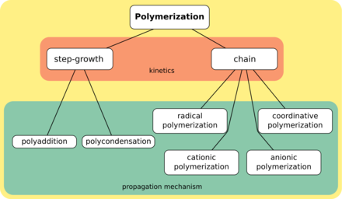

- The term "polymer" derives from the Greek word polus, meaning "many, much") and meros, meaning "part"), and refers to large molecules whose structure is composed of multiple repeating units, from which originates a characteristic of high relative molecular mass and attendant properties
- The most common macromolecules in biochemistry are biopolymers nucleic acids, proteins, and carbohydrates

- Nomenclature of macromolecules:
There are multiple conventions for naming polymer substances. Many commonly used polymers, such as those found in consumer products, are referred to by a common or trivial name. The trivial name is assigned based on historical precedent or popular usage rather than a standardized naming convention. Both the American Chemical Society (ACS)^{[62]} and IUPAC^{[63]} have proposed standardized naming conventions; the ACS and IUPAC conventions are similar but not identical.^{[64]} Examples of the differences between the various naming conventions are given in the table below:

Common name | ACS name | IUPAC name
Poly(ethylene oxide) or PEO | Poly(oxyethylene) | Poly(oxyethylene)
Poly(ethylene terephthalate) or PET | Poly(oxy-1,2-ethanediyloxycarbonyl-1,4-phenylenecarbonyl) | Poly(oxyethyleneoxyterephthaloyl)
Nylon 6 or Polyamide 6 | Poly[imino(1-oxo-1,6-hexanediyl)] | Poly[azanediyl(1-oxohexane-1,6-diyl)]

In both standardized conventions, the polymers' names are intended to reflect the monomer(s) from which they are synthesized (source based nomenclature) rather than the precise nature of the repeating subunit. For example, the polymer synthesized from the simple alkene ethene is called polyethene, retaining the -ene suffix even though the double bond is removed during the polymerization process:

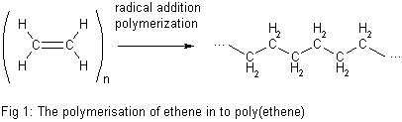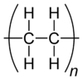

However, IUPAC structure based nomenclature is based on naming of preffered constitutional repeating unit,^{[65]} which in this case is just methylene -CH₂- unit and therefore the recommended name for ethene homopolymer is poly(methylene).

